Read the following resources before answering the questions below

· <http://www.cbc.ca/news/technology/emojis-forever-pringle-1.4577456>

· <http://www.cbc.ca/news/emoji-equality-google-1.3698970>

Guidelines for writing a supported opinion paragraph (SOP)

· <http://schools.peelschools.org/sec/fletchersmeadow/studentlife/OSSLTprep/Documents/Sample_%20Writing%20a%20Supported%20opinion%20paragraph.pdf>

Questions

2. List and explain three (3) examples of how "images are becoming the new mode of expression."

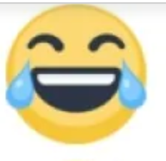

This expresses that someone is laughing, and they’re laughing so hard that there’s tears out

of their eyes.

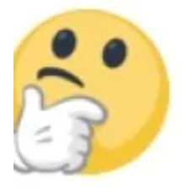

This represents that someone is thinking about a question or situation that they’re in.



This could represent that the person is happy about their life, whether that they have

accomplished anything, or just got something that they’ve been waiting for.

3. List and explain three (3) advantages of using emojis in communication.

They can express how you feel through text, without having to call them or talk in

person. They also allow you to post with them, so that everyone can see that same

expression instead of having to either post a video or showing everyone in person. The

last advantage would be that people could use emojis to indicate that you’re doing a certain activity, whether it be sports, or going to the airport, etc...

4. List and explain three (3) disadvantages of using emojis in communication

They could be used in a different manner, for example the eggplant like Ramona Pringle

said. They could also be interpreted incorrectly, and the receiver might think that you’re

in a different mood than you want to portray. The last disadvantage is that emojis are not fully supported on all devices, and one emoji could look different on another device receiving that emoji.

5. Write a supported opinion paragraph (SOP) that addresses the comment "nothing is more important than how emojis are replacing words.". (for or against)

Emojis are not replacing words. I believe so because emojis can vary in meaning. They are just pictures that are being displayed on a screen. Words actually mean something, and cannot be interpreted any way other than what you want them to mean. Words also have much more complex meanings than emojis. There isn’t an emoji for every word, and emojis are usually used as a side emphasis to what you said in text. This is why I believe that emojis will not replace words.

6. List and explain three (3) examples of how emoji equity affects users.

Emoji equity can affect users, because of how things work in real life. All races should be treated as equal, and so there would be an emoji for all the races. Men and women need to be equal, and so there needs to be an equal number of men and women emojis and variations so that people won’t be offended when the emoji that they’re looking for isn’t there but is in another form. The last way is if the person is a part of LGTBQ, and so there needs to be those emoji’s to support the community.

7. List and explain three (3) examples of how emoji equity is being addressed by companies such as Google.

Google is creating women emojis, and there are alot of jobs for all the women emojis. There are also different races for the women emojis, as they add the jobs. They also create the women emojis, to be equal to the men emojis that already exist.

8. Write a supported opinion paragraph (SOP) that addresses the twitter comment

“isn't there more serious issues to focus on in regards to women than emojis?” (for or against)

I believe that the twitter comment is wrong, because women are equal to men, and everyone deserves the same. This means that google needed to take action on the fact that they were unequal, and that they needed to add women emojis in order to make ends meet. The twitter commenter probably doesn’t care about how people think about equity, and that they should rethink their comment and how people would feel if there weren’t those emojis. This is why i believe that google made the right decision to take action and make women emojis.